Product Specifications

Table of Contents:

Modification History
Major Milestones
Abstract
Document References
Glossary
Class Diagram
Use Case Sequence Diagram
Use case 1
General Description
Sequence Diagram
Use case 2
General Description
Sequence Diagram
User Interface
Others

Modification History

9/30/2016/Added class diagram, scenario list, and sequence diagrams for the four Use Case 6 scenarios./SG

10/02/2016/Added four different sequence diagrams./ZD

10/02/2016/Added four different sequence diagrams./KQ

10/02/2016/Added four different sequence diagrams./JD

10/2/2016/Added four sequence diagrams./BW

10/29/2016/Added Matchand GUI class state diagrams./SG

10/30/2016/Added updated sequence diagrams./BW

11/2/2016/Added the new class diagram./SG

11/5/2016/Added two finite state machine./KQ

11/5/2016/Added finite state diagram/BW

11/5/2016/Formatting and Use Case 7 Sce. 1 #6 Edit./ZD

11/6/2016/Updated sequence diagram./JD

11/6/2016/Added short explanation for classes not needing state diagrams./SG

11/6/2016/Add finite state diagram for column and diagonal./ZD

Major Milestones

Date | Milestone

Abstract

Document References
Document | Location

Glossary

Term | Definition

Acronym | Meaning

Class Descriptions
The following is a brief description of each class as well as a short list of its main responsibilities.

Square

Class type: Entity

Description:

The Square class stores information about a square on the tic-tac-toe game board such as whether the square is occupied, and if so, but which player.

Responsibilities:

Send message to Row, Column, or Diagonal that indicates whether or not it is occupied.

Send message to MatchController to signal that a click event has occurred.

Row, Column, Diagonal

Class type: These are all entity classes

Description:

Represent a row, column, or diagonal, respectively, on the game board. Thus, each Row and Column references 5 Square objects and Diagonals reference 4 or 5 Squares.

Responsibilities:

Request information from Square about whether or not it is occupied/and by what Player.

Return information to GameBoard about whether or not there is a winner or all squares are taken.

GameBoard

Class type: Entity

Description:

This represents the 5 x 5 tic-tac-toe game board. It stores arrays of Row, Column, and Diagonal objects.

Responsibilities:

Request from Row,Column, or Diagonal information about their current state.

Notify Match that there is a winner or tie.

Provides information to GameBoardController class about available squares for when computer player makes turn.

GameBoardController

Class type: Control

Description:

This control class makes the move for a computer player when applicable.

Responsibilities:

Receives request from MatchController to select a Square for the computer.

Requests info from GameBoard about the Squares available.

Sends message to Square that it has been selected.

Player

Class type: Entity

Description:

This represents a player (human or computer) taking part in a Match.

Responsibilities:

Communicates with Square to let the Square know the ID/name of person who has chosen it.

Communicates with Match to let Match know the name/ID of person whose turn it is.

MemoryController

Class type: Control

Description:

This control class handles reading/writing match records to memory.

Responsibilities:

Receives message from MatchController to write the results to a file.

Sends information to GUI for win/loss displays.

Match

Class type: Entity

Description:

Stores information related to the current match being played. Encapsulates references to two Player instances and a GameBoard instance.

Responsibilities:

Requests information from GameBoard about the status of the match.

MatchController

Class type: Control

Description:

This control class initiates various algorithms for the Match class, such as checking if there is a winner or tie.

Responsibilities:

Send message to MemoryController about recording the results of a finished match.

Send message to GUI when match is finished. Also, receive message from GUI about a new match starting.

Request information from Match about the status of the Match’s GameBoard object.

Receive click event from Square as a signal that processing is needed.

GUI

Class type: Boundary

Description:

Displays the menus and game board to the users. Also displays the prompts, such as which player’s turn it is.

Responsibilities:

Receive input from the use case actors, including initiating the propagation of .click() events.

Display output to the users.

Class Diagram

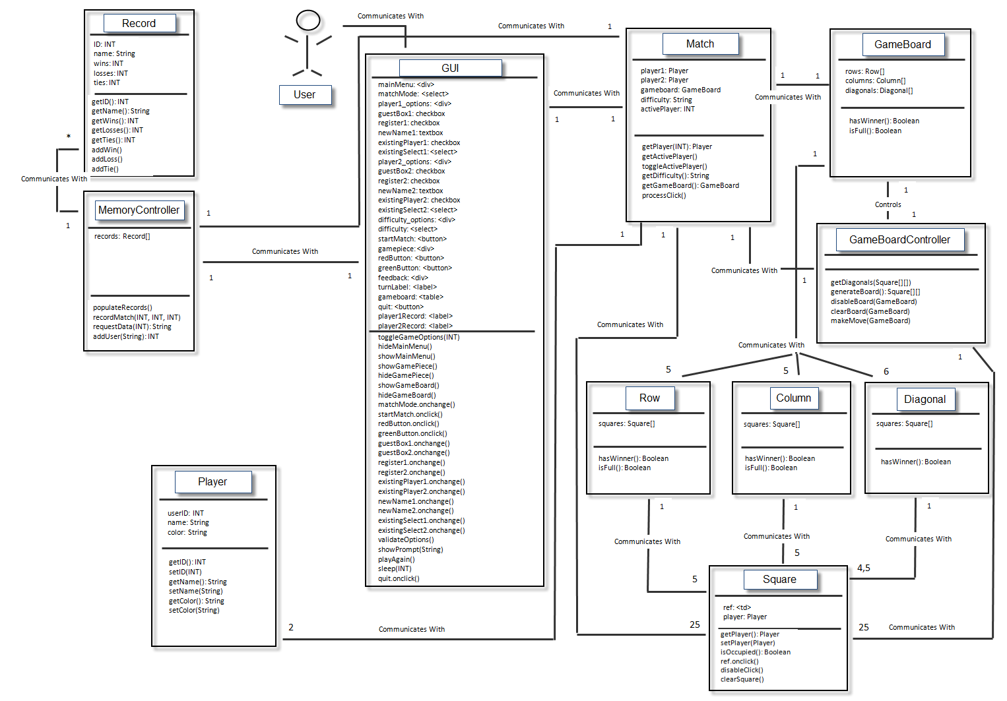
DETAILED CLASS DESCRIPTIONS
The following is a detailed explanation for each instance variable and method of each class featured in the revised class diagram:

Class: Square
Description: A square represents an instance of a square on a tic-tac-toe game board. It is what the user clicks on to make his or her selection during a match.

Constructor: new Square (td)
Parameter: td is a reference to a <td> tag in the html document.

Instance variables:

Name | Type
ref | Reference to a <td> element in the html
player | Player

Methods:

setPlayer (Player)
Argument: Player object
Description: sets the instance variable player to the object passed in as the parameter.

getPlayer()
Arguments: None
Description: Return the Player reference pointed to by the player instance variable.

isOccupied()
Arguments: None
Description: Boolean for whether or not a Player has claimed this Square.

ref.onclick()
Arguments: None
Description: The event handler that fires when a Player click on the Square.

disableClick()
Arguments: None
Description: Detaches the onclick() event handler from the Square.

clearSquare()
Arguments: None
Description: Removes the game piece from a Square and sets the player instance variable to null. It resets the Square for a new Match.

Class: Player
Description: This class represents one of two players participating in a match.

Constructor: new Player (id, player_name, player_color)
Arguments: id: INT representing the unique ID number for that registered user
Player_name: String representing the user’s name
Player_color: String representing the color game piece the user selected

Instance variables:

Name | Type
userID | Integer
name | String
color | String

Methods:

getID()
Arguments: None
Description: returns the userID attribute for the Player

setID(id)
Arguments: id:INT
Description: sets the userID instance variable to the id argument provided

getName()
Arguments: None
Description: returns the name instance variable for the Player

setName(name)
Arguments: name:String
Description: sets the name instance variable for the Player

getColor()
Arguments: None
Description: returns the value of the color instance variable for the Player

setColor(color)
Arguments: color: String
Description: sets the color instance variable to the string value specified

Class: Row
Description: This class represents a row of five squares on a game board

Constructor: new Row (square_array)
Argument: square_array: an array of type Square

Instance variables:
Name | Type
squares | Square []
Methods:

hasWinner()
Arguments: None
Description: Returns a Boolean for whether or not this Row has four adjacent Squares with the same Player

isFull()
Arguments: None
Description: Returns a Boolean for whether or not all of the Squares in this Row are occupied.

Class: Column
Description: This class Represents a column of five Squares on a game board.

This class has the same constructor arguments, instance variables, and methods of the Row class.

Class: Diagonal
Description: This class represents one of the four or five-square diagonals on a game board. There are six in total on a game board.

This class has the same constructor arguments, instance variables, and methods of the Row class, with the exception of the isFull() method.

Class: GameBoard
Description: This class represents the 5 x 5 grid of squares for a game of tic-tac-toe.

Constructor: new GameBoard(array)
Arguments: a 2D array of Squares

Instance Variables:

Name | Type
rows | Row []
columns | Column []
diagonals | Diagonal []

Methods:

hasWinner()
Arguments: None
Description: Returns a Boolean for whether or not a player has won. The GameBoard checks its Rows, Columns, and Diagonals to see if this is the case.

isFull()
Arguments: None
Description: Returns a Boolean for whether or not the GameBoard has any vacant squares. The GameBoard checks each Row’s isFull() method to see if this is the case.

Class: Match
Description: Represents an instance where two players are facing each other on a tic-tac-toe game board.

Instance variables:
Name | Type
player1 | Player
player2 | Player
gameboard | GameBoard
difficulty | String (“Easy”, “Medium”, “Hard”, “None”)
activePlayerNumber | INT (1 or 2)

Methods:

getPlayer(val)
Argument: val: INT (only valid if val == 1 or 2)
Description: Returns the reference to player1 or player2 instance variable based on which argument value is passed.

getActivePlayer()
Argument: None
Description: Returns a reference to the Player object representing which Player whose turn it currently is.

toggleActivePlayer()
Arguments: None
Description: Switches turns from one Player to another in the Match

getDifficulty()
Arguments: None
Description: Returns a string representing the difficulty of the Match

getGameBoard()
Arguments: None
Description: returns a reference to the GameBoard associated with this Match.

processClick()
Arguments: None
Description: Checks the Match’s GameBoard for a win or tie after a Square is clicked. If a Match is over, notifies the MemoryController to write the results of the Match.

Class: Record
Description: A Record stores the historic win-loss-tie data for a registered user along with the user’s unique user identification number and name.

Constructor: new Record(number, fName)
Arguments: number: INT,
fName: String

Instance variables:
Name | Type
ID | INT
name | String
wins | INT
losses | INT
ties | INT

Methods:

getID()
Arguments: None
Description: returns the ID for the registered user

getName()
Arguments: None
Description: return the name for the registered user

getWins()/getLosses()/getTies()
Arguments: None
Description: returns the number of wins/losses/ties in that user’s history

addWin()/addLoss()/addTie()
Arguments: None
Description: increment the number of wins/losses/ties in that user’s history

Class: MemoryController
Description: This control class is tasked with writing and retrieving all of the historic match and user data from the localStorage variable of the web browser.

Constructor: new MemoryController()
Arguments: None

Instance variables:
Name | Type
records | Record[]

Methods:
populateRecords()
Arguments: None
Description: Retrieves all of the historic data stored in the web browser for each Match. The method also updates the dropdown menus on the main menu to reflect all the registered users.

recordMatch(id1, id2, isTie)
Arguments: id1: INT,
Id2: INT,
isTie: INT (0 or 1)
Description: Writes the results of the latest Match to localStorage. Id1 represents the userID for the winner, id2 represents the userID for the match loser. However, if isTie = 1, then the match is a tie. If isTie = 0, then it is a match with a winner and loser.

requestData(id)
Arguments: id: INT
Description: Returns a String displaying the number of wins, losses, and ties for the user with an identification number equal to the id that was passed in as an argument.

addUser(name)
Arguments: name: String
Description: Adds a new registered user to the repository of user names. The new user’s name is passed in as the argument.

Class: GameBoardController
Description: This global control class performs various algorithms useful to the application such as setting up a GameBoard object or making a move for the computer player. It has no instance variables of its own

Methods:

getDiagonals(square_array)
Arguments: square_array: Square[][]
Description: Receives a 2D Square array and returns all of the diagonals on a 5 x 5 grid

generateBoard()
Arguments: None
Description: Grabs a reference to each <td> elements in the html, creates the Square objects, and returns a 2D array of Squares that will be used in the GameBoard class constructor.

disableBoard(board)
Arguments: board: GameBoard
Description: Disables the onclick event for every Square on the GameBoard passed as an argument.

clearBoard(board)
Arguments: board: GameBoard
Description: Removes the background image and player attribute for every Square on the GameBoard object passed in as the argument

makeMove(board)
Arguments: board: GameBoard
Description: performs the AI algorithm for computer players and selects one of the Squares on the board based on the current Match’s difficulty setting.

Class: GUI
Description: This boundary class serves as the visual interface for the user of the tic-tac-toe application. It stores references to most of the html elements rendered on the webpage.

Constructor: new GUI()
Arguments: None

Instance Variables:

Name | Type
mainMenu | <div> reference
matchMode | <select> reference
player1_options | <div> reference
guestBox1 | Checkbox
register1 | Checkbox
newName1 | Textbox
existingPlayer1 | Checkbox
existingSelect1 | <select> reference
player2_options | <div> reference
guestBox2 | Checkbox
Register2 | Checkbox
newName2 | Textbox
existingPlayer2 | Checkbox
existingSelect2 | <select> reference
difficulty_options | <div> reference
difficulty | <select> reference
startMatch | <button> reference
gamepiece | <div> reference
redButton | <button> reference
greenButton | <button> reference
feedback | <div> reference
turnLabel | <label> reference
gameboard | <div> reference
quit | <button> reference
player1Record | <label> reference
player2Record | <label> reference

Methods:

toggleGameOptions(val)
Argument: val: INT
Description: Toggles the display for computer or Player 2 options based on which match mode is selected (Player vs. Computer or Player vs. Player).

hideMainMenu()
Description: hides the main menu after “Start Match” has been clicked.

showMainMenu()
Description: Displays the main menu again after a match.

hideGamePiece()
Description: hides the game piece selection menu on the screen.

showGamePiece()
Description: Displays the game piece selection menu on the screen.

hideGameBoard()
Description: hides the game board on the screen.

showGameBoard()
Description: Displays the game board on the screen.

matchMode.onchange()
Description: Event handler that fires when the Player vs. Computer or Player vs. Player selection is changed. This alters the options visible on the main menu.

startMatch.onlick()
Description: Event handler that fires when “Start Match” is clicked. This has the effect of hiding the main menu and showing the options for selecting a game piece.

redButton.onclick()
Description: Event handler that fires when player 1 chooses the game piece on the left. It causes the game piece selection menu to be hidden and the match to begin.

greenButton.onclick()
Description: Event handler that fires when player 1 chooses the game piece on the right. It causes the game piece selection menu to be hidden and the match to begin.

guestBox1.onchange()
Description: Event handler that fires when the “Play as Guest” checkbox for Player 1 is clicked.

guestBox2.onchange()
Description: Event handler that fires when the “Play as Guest” checkbox for Player 2 is clicked.
register1.onchange()
Description: Event handler that fires when “New User” checkbox for Player 1 is clicked.

register2.onchange()
Description: Event handler that fires when “New User” checkbox for Player 2 is clicked.

existingPlayer1.onchange()
Description: Event handler that fires when “Existing User” checkbox for Player 1 is clicked.

existingPlayer2.onchange()
Description: Event handler that fires when “Existing User” checkbox for Player 2 is clicked.

newName1.onchange()
Description: Event handler that fires when the content in text box for Player 1 is altered.

newName2.onchange()
Description: Event handler that fires when the content in text box for Player 2 is altered.

existingSelect1.onchange()
Description: Event handler that fires when the select box for existing user for Player 1 is changed.

existingSelect2.onchange()
Description: Event handler that fires when the select box for existing user for Player 2 is changed.

validateOptions()
Description: Check the current state of the main menu for valid input. If invalid or incomplete, the “Start Match” button should be disabled.

showPrompt(message)
Argument: message: String
Description: This updates the message inside turnLabel to show a prompt to the user such as whose turn it is.

playAgain()
Description: Asks user if they want to play another match with the same settings. If they do, the gameboard continues to display and a new match begins. Otherwise, the user returns to the main menu.

sleep(m)
Argument: m: INT
Description: Pause any further output from the GUI for m milliseconds

quit.onclick()
Description: Event handler that fires when the “Quit” button is clicked

Use Case Scenarios
Below are several normal and exception scenarios for each use case. These are the scenarios from which the sequence diagrams developed thus far were derived.

USE CASE 1: Starting the Tic-Tac-Toe Application

Normal Scenario
A user wishes to open the tic-tac-toe application in his web browser.
1. The user navigates to the directory on his system where the .html, .css, .js, and other supporting files are located.
2. The user double clicks the .html file in the directory.
3. The default browser opens up on the user’s computer.
4. The home menu displays for the user:
4.1 A dropdown box to select number of players is rendered on screen.
4.2 A checkbox for the option of playing as guest is rendered in addition to a selection box for inputting a user’s name.
Exception Scenario
A user wishes to open the tic-tac-toe application on his web browser, but the page cannot be located.
1. The user goes to the Bookmarks or History in his browser.
2. User clicks to open the tic-tac-toe application.
3. Web browser reports that the desired file cannot be located.
4. User must navigate to the USB or other storage device where a backup copy of the necessary files is located.
5. User saves copy of the application’s .html, .css., and .js files to the desired directory.
6. User either proceeds with Step 1 again OR proceeds with Step 1 of the normal scenario alternative for this use case.

USE CASE 2: Choosing the Game Options

Normal Scenario 1
A user wishes to set up a game against the computer. The user will play as a registered user. The Medium difficulty level will be chosen for the computer.
1. User navigates to index.html in his browser as specified in Use Case 1.
2. User accepts default value dropdown selection box that defaults to “Player vs. Computer.”
3. User leaves the “Play as Guest” checkbox blank.
4. User mouses down to a select box that has pre-filled options based on previous users.
5. User selects the option “Stephen.”
5.1 An invisible textbox will store a unique numeric identifier or the name for this user so that when the results at the end of the match are recorded the application knows the identity of the user.
5.2 Stephen’s win-loss-tie record: 8 Wins, 4 Losses, 2 Ties is displayed below.
6. User mouses over Difficulty dropdown box and selects “Medium.”
7. User clicks “Start Match.”
8. The options menu disappears and the menu for choosing a game piece displays.

Normal Scenario 2
Two users wish to set up a match against each other. The first player is a guest and the other wishes to play with his registered name.
1. One of the users navigates to the index.html page in the web browser.
2. A user clicks the dropdown selection box to select “Player vs. Player.”
2.1 A second checkbox for the “Play as Guest” option appears.
2.2 A second textbox for username entry appears.
2.3 The difficulty option is now hidden since computer isn’t selected.
3. The first player clicks the checkbox for “Play as Guest.”
4. The second player then leaves the “Play as Guest” checkbox blank.
5. The second player scrolls down on the name selection box and chooses “Brent.” This
causes Brent’s record of 6 Wins, 3 Losses, 0 Ties to be displayed below.
6. One of the players clicks “Start Match.”
7. The selection menu used thus far is hidden and the menu for selection game pieces appears.

Exception Scenario
Two users wish to set the parameters for a new match. However, the second player chooses the same username as the first player.
1. One of the users navigates to the index.html page in the web browser.
2. A user clicks the dropdown selection box to select “Player vs. Player.”
2.1 A second checkbox for the “Play as Guest” option appears.
2.2 A second textbox for username entry appears.
3. The first player leaves the checkbox for playing as a guest blank and selects “Stephen” from the username text selection box.
4. The second player does this same for his respective options.
5. Clicking “Start Match” button raises an alert where a message box appears and says “Players must choose different names.”
6. Step 5 repeats until either player 1 or 2 changes their name selection.

USE CASE 3: Selecting a Game Piece

Normal Scenario
A user has chosen the options for starting a match against the computer. He will now choose his game piece.
1. After clicking “Start Match,” a new menu becomes visible that says “Select Game Piece.”
2. Two images are shown as choices. The user clicks the image on the right.
3. The menu disappears and the game board disappears.
4. The match begins, with the chosen image designating the squares selected by the user and the other image designating the computer’s choices.

Exception Scenario
Two players have set up a match against each other. However, the images are not displaying when it is time to select game pieces.
1. After clicking “Start Match,” a new menu becomes visible that says “Select Game Piece.”
2. Where two images should appear as choices, there are just empty boxes with alternate text saying “Piece1” and “Piece2.”
3. One of the users closes the browser and locates the backup files.
4. User copies files into the desired directory and reloads the page. Without performing this step, the pictures will never render during the match.

USE CASE 4: Selecting a Square on the Game Board

Normal Scenario
We assume two human players, Zach and Kevin, are in the middle of a match. It is now Zach’s turn to select a square.
1. At the top of the game board, there is a text label that reads “Zach’s turn.”
2. Zach takes control of the mouse and locates a square on the game board that he wishes to claim.
3. Zach hovers over the desired square with his mouse. CSS functionality gives some feedback by adding a small border to the square.
4. Zach clicks the desired square.
5. The square Zach has clicked now displays Zach’s game piece.
6. The game board checks to see if either player has four game pieces that are adjacent by examining the horizontal, vertical, and diagonal possibilities.
7. No winner exists yet, so the text label now reads “Kevin’s turn.”

Exception Scenario
Zach and Kevin continue to play their match. Kevin opts to click on a square that has already been claimed by Zach.
1. At the top of the game board, there is a text label that reads “Kevin’s turn.”
2. Kevin takes control of the mouse and locates a square on the game board that he wishes to claim.
3. Kevin hovers over the desired square with the mouse. CSS functionality gives some feedback by adding a small border to the square.
4. Kevin clicks the desired square, which already has Zach’s game piece on it.
5. Nothing happens. The algorithm does not check to see if there is a winner yet. It remains Kevin’s turn until he opts to click on a square that is not yet claimed.

USE CASE 5: Testing for a Winner or a Tie
*By disabling the click event for squares, we should be able to avoid the exception for this case.

Normal Scenario 1
Zach and Kevin are playing a match against each other. Kevin has just clicked on a square that results in him having four adjacent squares in a vertical fashion.
1. Kevin clicks on his chosen square and the square renders his game piece to designate his selection.
2. The click event for all squares on the game board are disabled.
3. The game board checks all rows to see if there is any player with four adjacent squares in a horizontal fashion. This is not the case, so it keeps checking another possibility:
4. The game board check all columns to see if there is any player with four adjacent squares in a vertical fashion. Kevin has claimed four adjacent squares in the second column, so the game board can report a winner.
5. Text label at the top of the board reads “Kevin Wins!”
6. Match results are recorded in the storage format.
7. A dialog box appears with the question, “Play again?” and use case 6 executes.

Normal Scenario 2
Zach and Kevin are two users playing each other in a match. The match has reached a point where all the squares except one have been selected. Kevin chooses the final square available, and it does not result in him getting four adjacent squares.
1. The first four steps occur as listed in Normal Scenario 1 for this use case, except checking the columns does not lead to a winner.
2. The game board proceeds to check the possible diagonal possibilities to see if there is a winner. This returns no winner.
3. The game board checks to see if there are any vacant squares. This returns false.
4. Text label at the top of the board reads “It’s a tie!”
5. Match results are recorded in the storage format.
6. A dialog box appears with the question, “Play again?” and use case 6 executes.

USE CASE 6: Replaying a Match

Normal Scenario 1
A user named Stephen has just played a match with the computer and the computer has been victorious. Stephen was playing with the Hard difficulty setting chosen.
1. Text label above the game board reads “Computer Wins!”
2. Dialog box appears on the screen and asks Stephen “Play again?”
3. Stephen clicks “Yes”
4. Second dialog appears on the screen and asks Stephen “Play with same settings?”
5. Stephen clicks “Yes”
6. The game board is cleared and the click event is restored for the squares. A new match begins with the same Hard difficulty.
7. Text label above the game board reads “Stephen’s turn.”

Normal Scenario 2
A user named Jomar has just played a match with the computer and been victorious. Jomar was playing with the Medium difficulty setting chosen. Jomar wants to replay, but with the Hard setting. Therefore, changing the setting will be required.
1. Text label above the game board reads “Jomar Wins!”
2. Dialog box appears on the screen and asks Jomar “Play again?”
3. Jomar clicks “Yes”
4. Second dialog appears on the screen asks Jomar “Play with the same settings?”
5. Jomar clicks “No”
6. Game board is cleared and hidden. The home menu that shows the “Player vs. Computer” dropdown selection box is again visible.

Normal Scenario 3
A user named Brent has just defeated Stephen. They don’t wish to play another match, so Brent will choose to not play another match.
1. Text label above the game board reads “Brent Wins!”
2. Dialog box appears on the screen and asks “Play again?”
3. Brent clicks “No”
4. The game board is cleared and hidden. The home menu that shows the “Player vs. Computer” dropdown selection box is again visible.

Exception Scenario
Stephen has defeated the computer on Easy difficulty. However, Stephen has disabled dialog boxes on the webpage.
1. Text label above the game board reads “Stephen Wins!”
2. Dialog box fails to appear on the screen to get input from Stephen.
3. An auxiliary set of buttons appears below the game board. One reads “Play again with same settings.” The other reads “Return to home screen.”
4. Stephen clicks “Play again with same settings.”
5. The game board is cleared and the square click events are restored.
6. Text label reads “Stephen’s turn” and a new match resumes with Easy difficulty.

USE CASE 7: Quitting Mid-Match

Normal Scenario 1
Stephen has run out of time and must get to class while playing Zach. He wants to quit mid-match.
1. The text label above the game board reads “Stephen’s turn.”
2. Stephen clicks the button below the game board that reads “Quit.”
3. A dialog box appears and reads “Are you sure you want to quit? This will result in a loss for Stephen.”
4. Stephen clicks “Yes”
5. The results of the match are recorded in the storage mechanism, showing Zach as the winner and Stephen as the loser.
6. The game board is cleared and hidden. The screen now displays “Play again with same settings?”

Normal Scenario 2
Stephen wants to quit in his match against Zach. However, he changes his mind when he finds out that it will record a loss for his record.
1. The text label above the game board reads “Stephen’s turn.”
2. Stephen clicks the button below the game board that reads “Quit.”
3. A dialog box appears and reads “Are you sure you want to quit? This will result in a loss for Stephen.”
4. Stephen clicks “No”
5. The match resumes where Stephen is free to select a square that has not been selected.

Exception Scenario
Zach chooses to quit during his match against Jomar. However, the users have disabled further dialog boxes on the page.
1. The text label above the game board reads “Zach’s turn.”
2. Zach clicks the button below the game board that reads “Quit.”
3. The dialog button fails to display.
4. The game resumes where Zach is free to select a square.
5. Zach hovers over “Quit” again and notices a tooltip that reads “Please enable dialog buttons.”

Use Case Sequence Diagrams
Use Case 1 Scenario 1: Normal

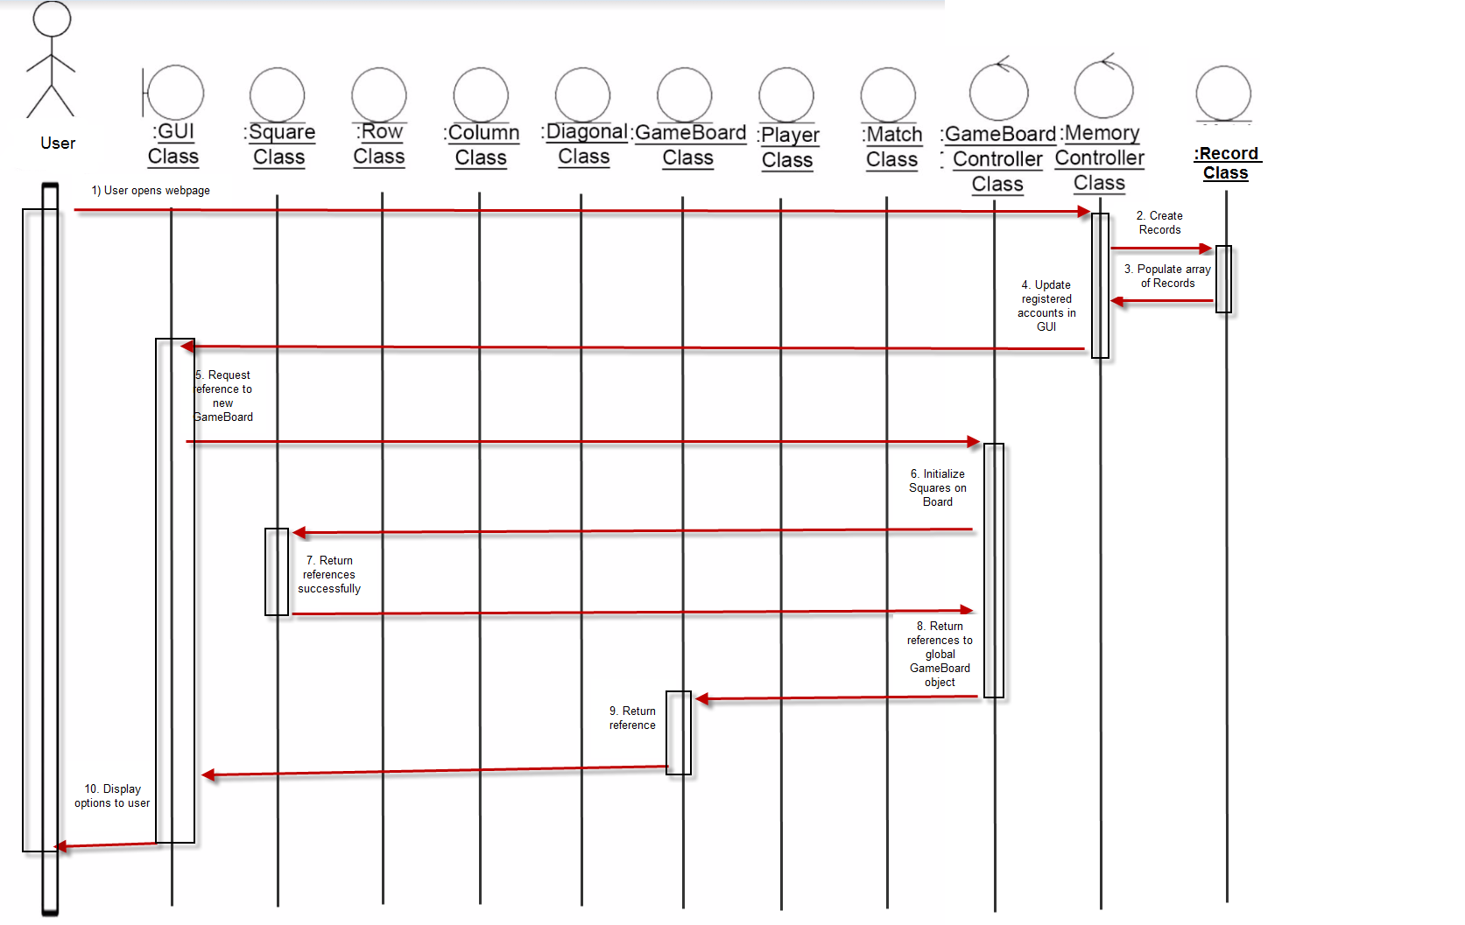

Use Case 1 Scenario 2: Exception

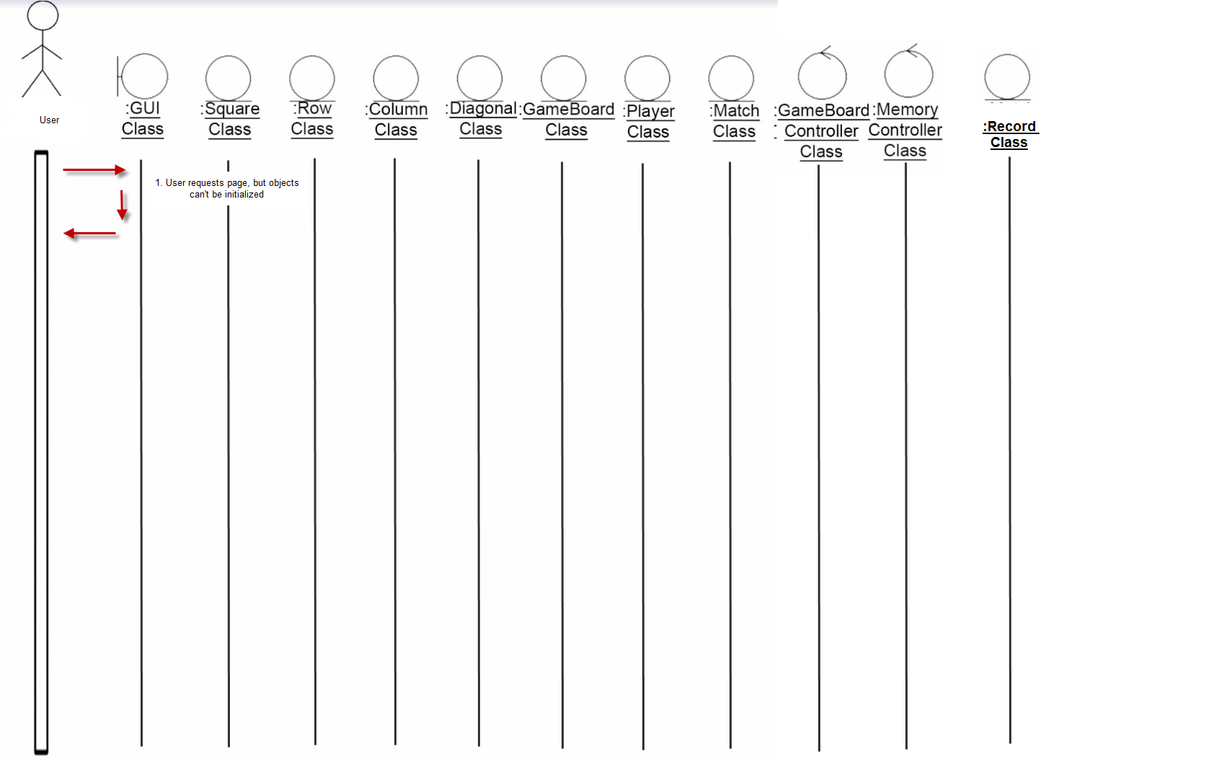

Use Case 2 Scenario 1
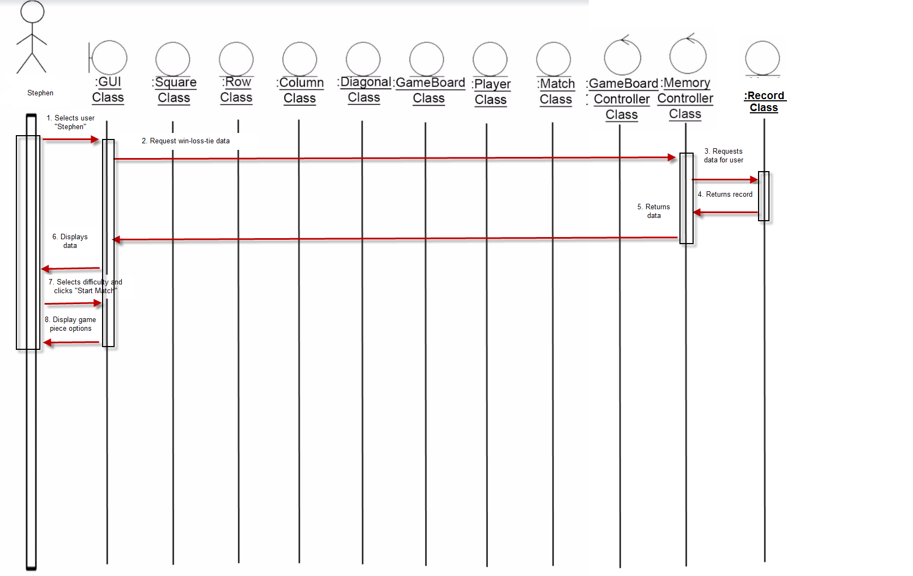

Use Case 2 Scenario 2
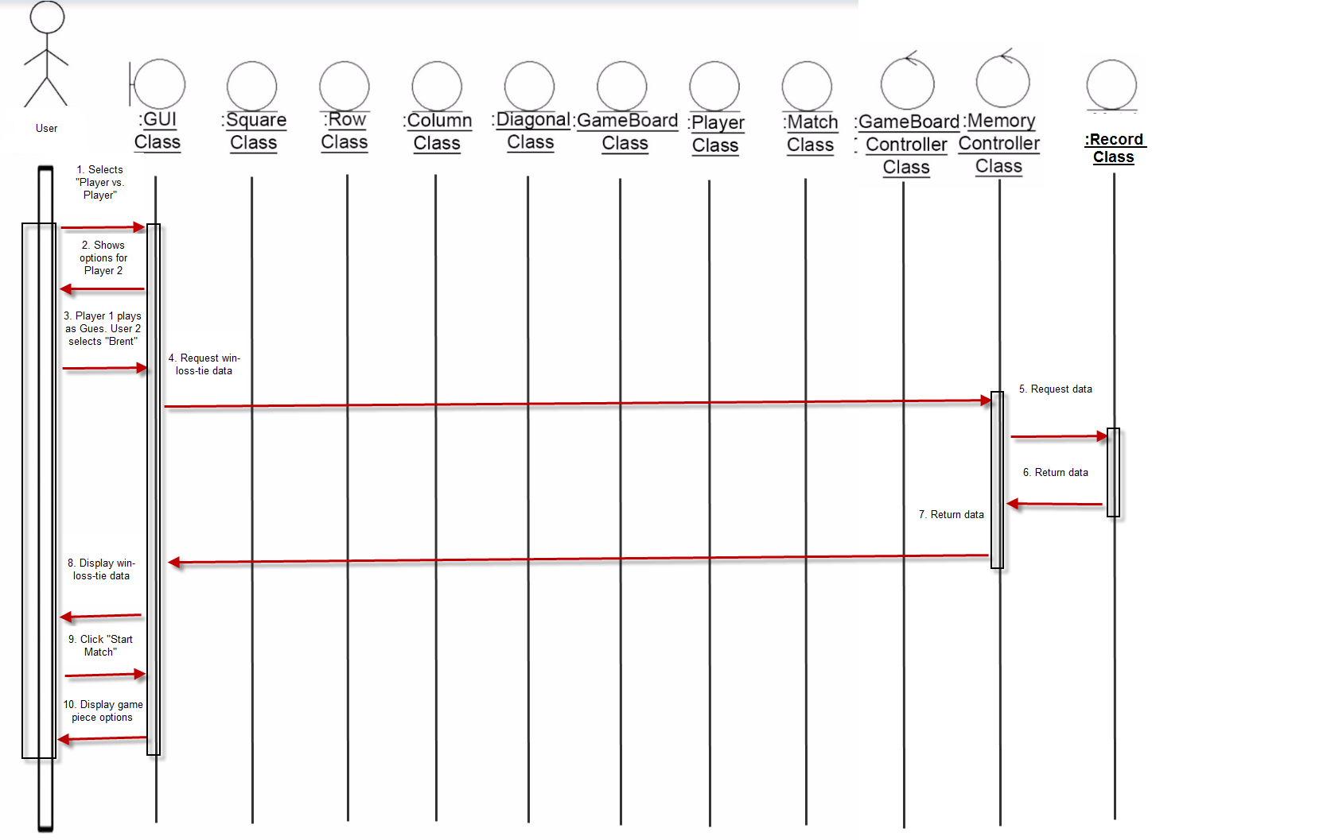

Use Case 2 Exception
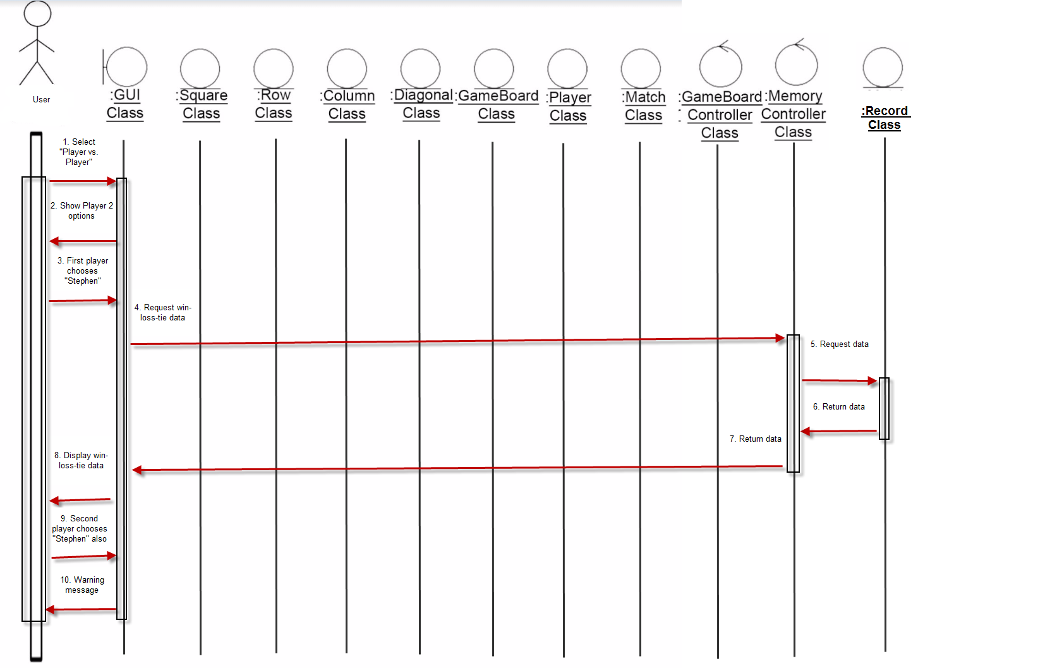

Use Case 3 Scenario 1
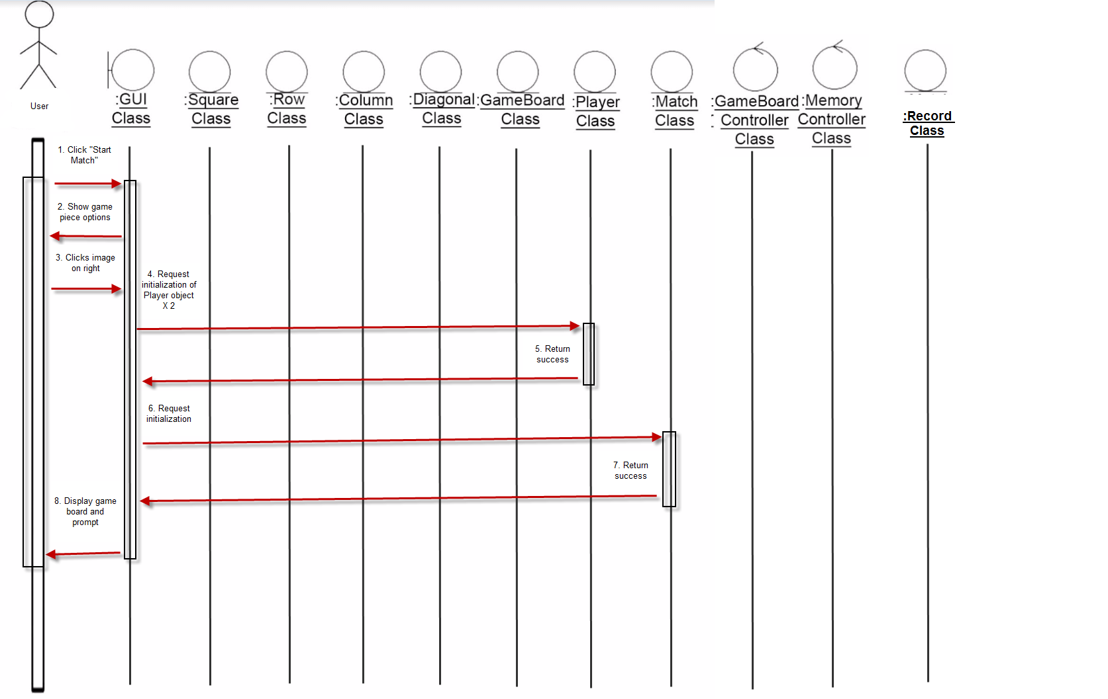

Use Case 3 Scenario 2
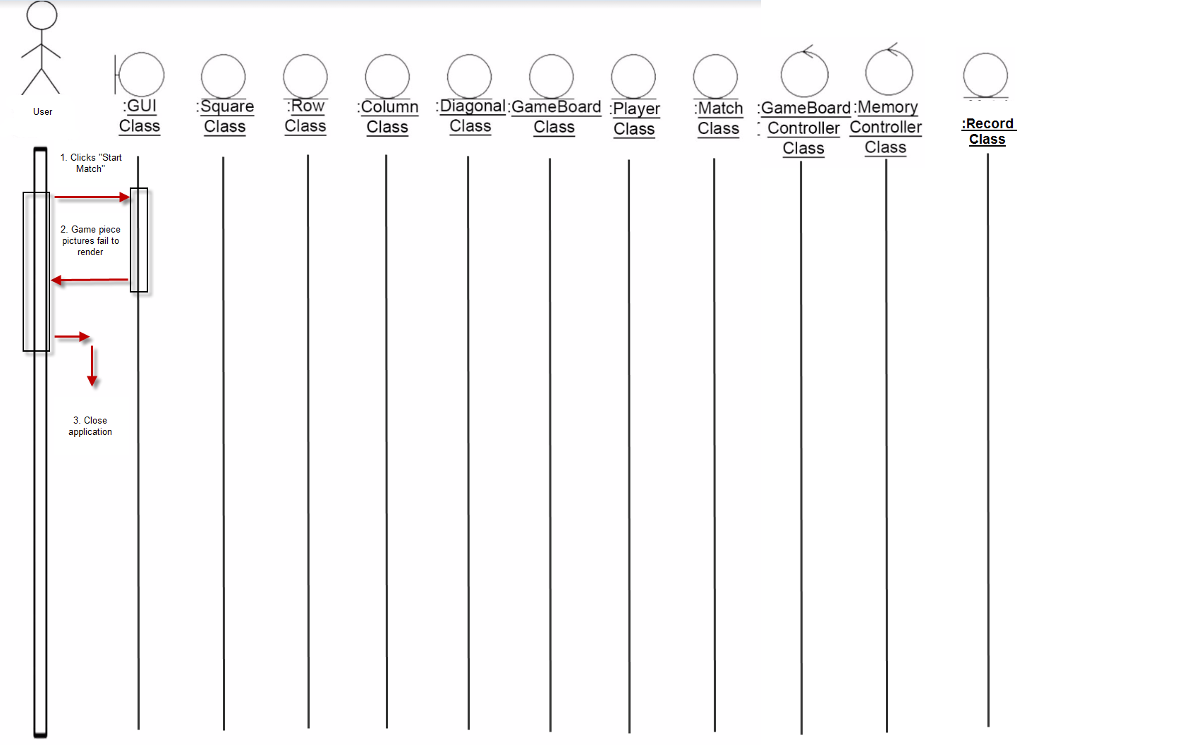

Use Case 4 Scenario 1
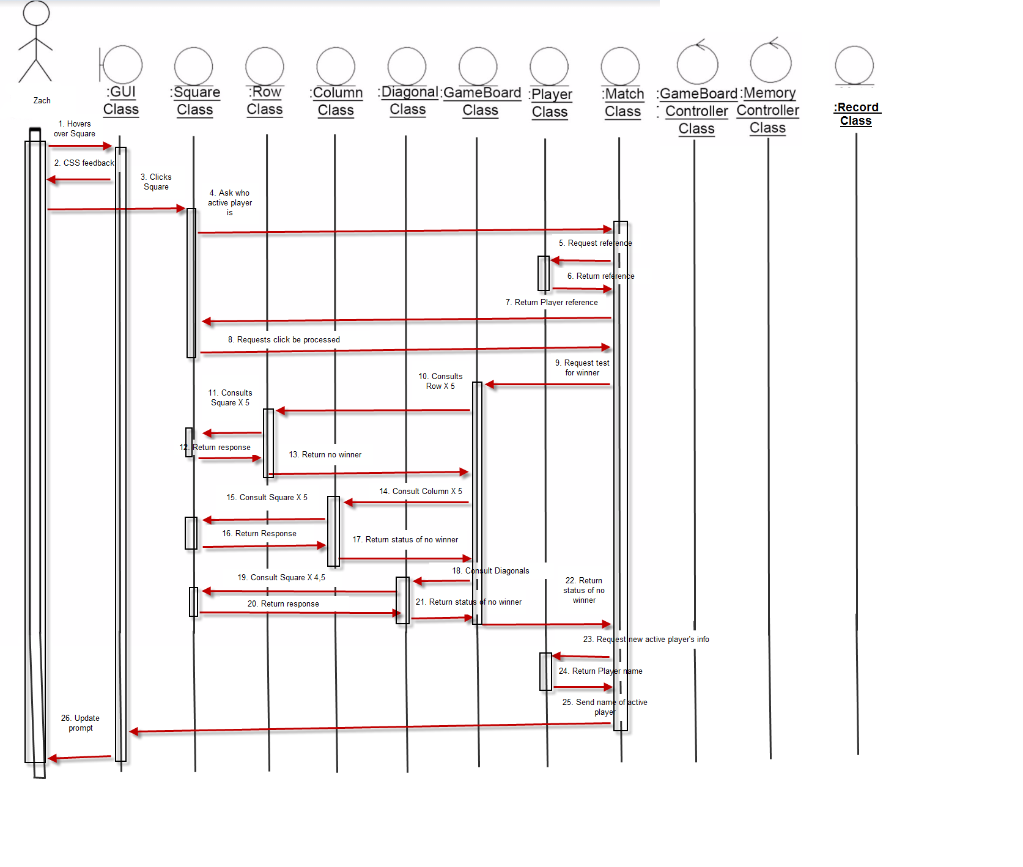

Use Case 4 Exception
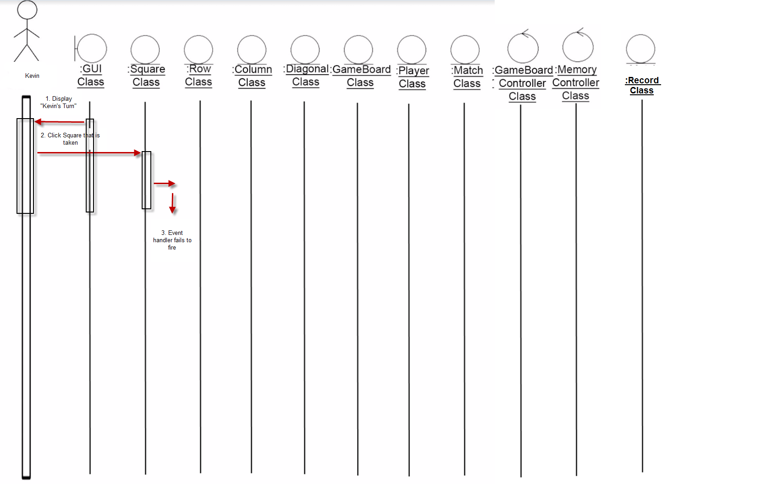

Use Case 5 Scenario 1
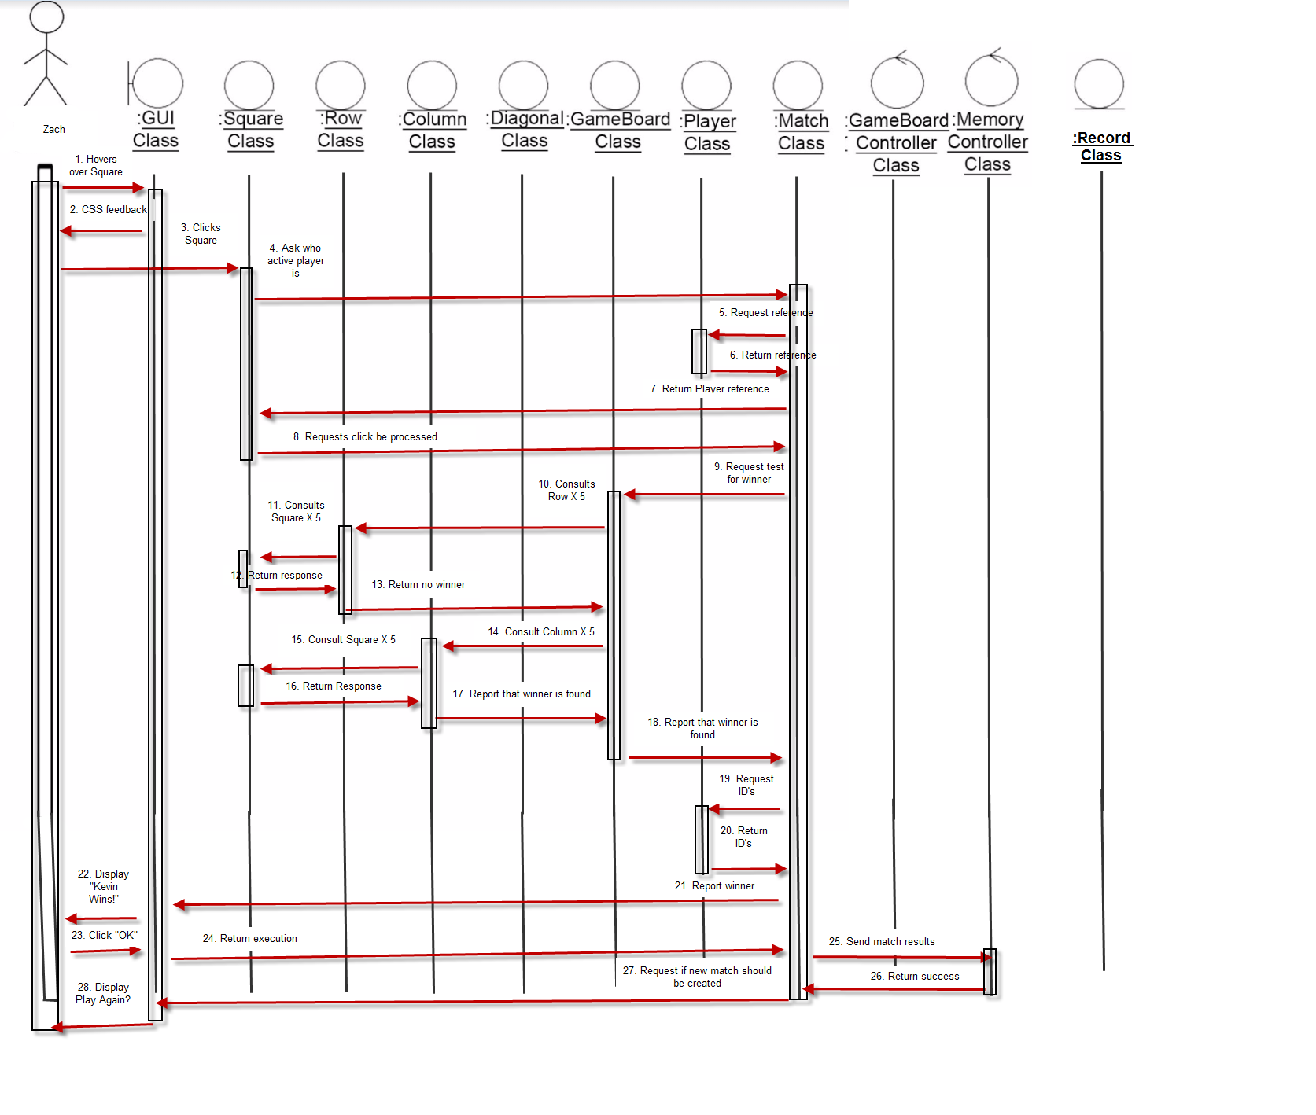

Use Case 5 Scenario 2
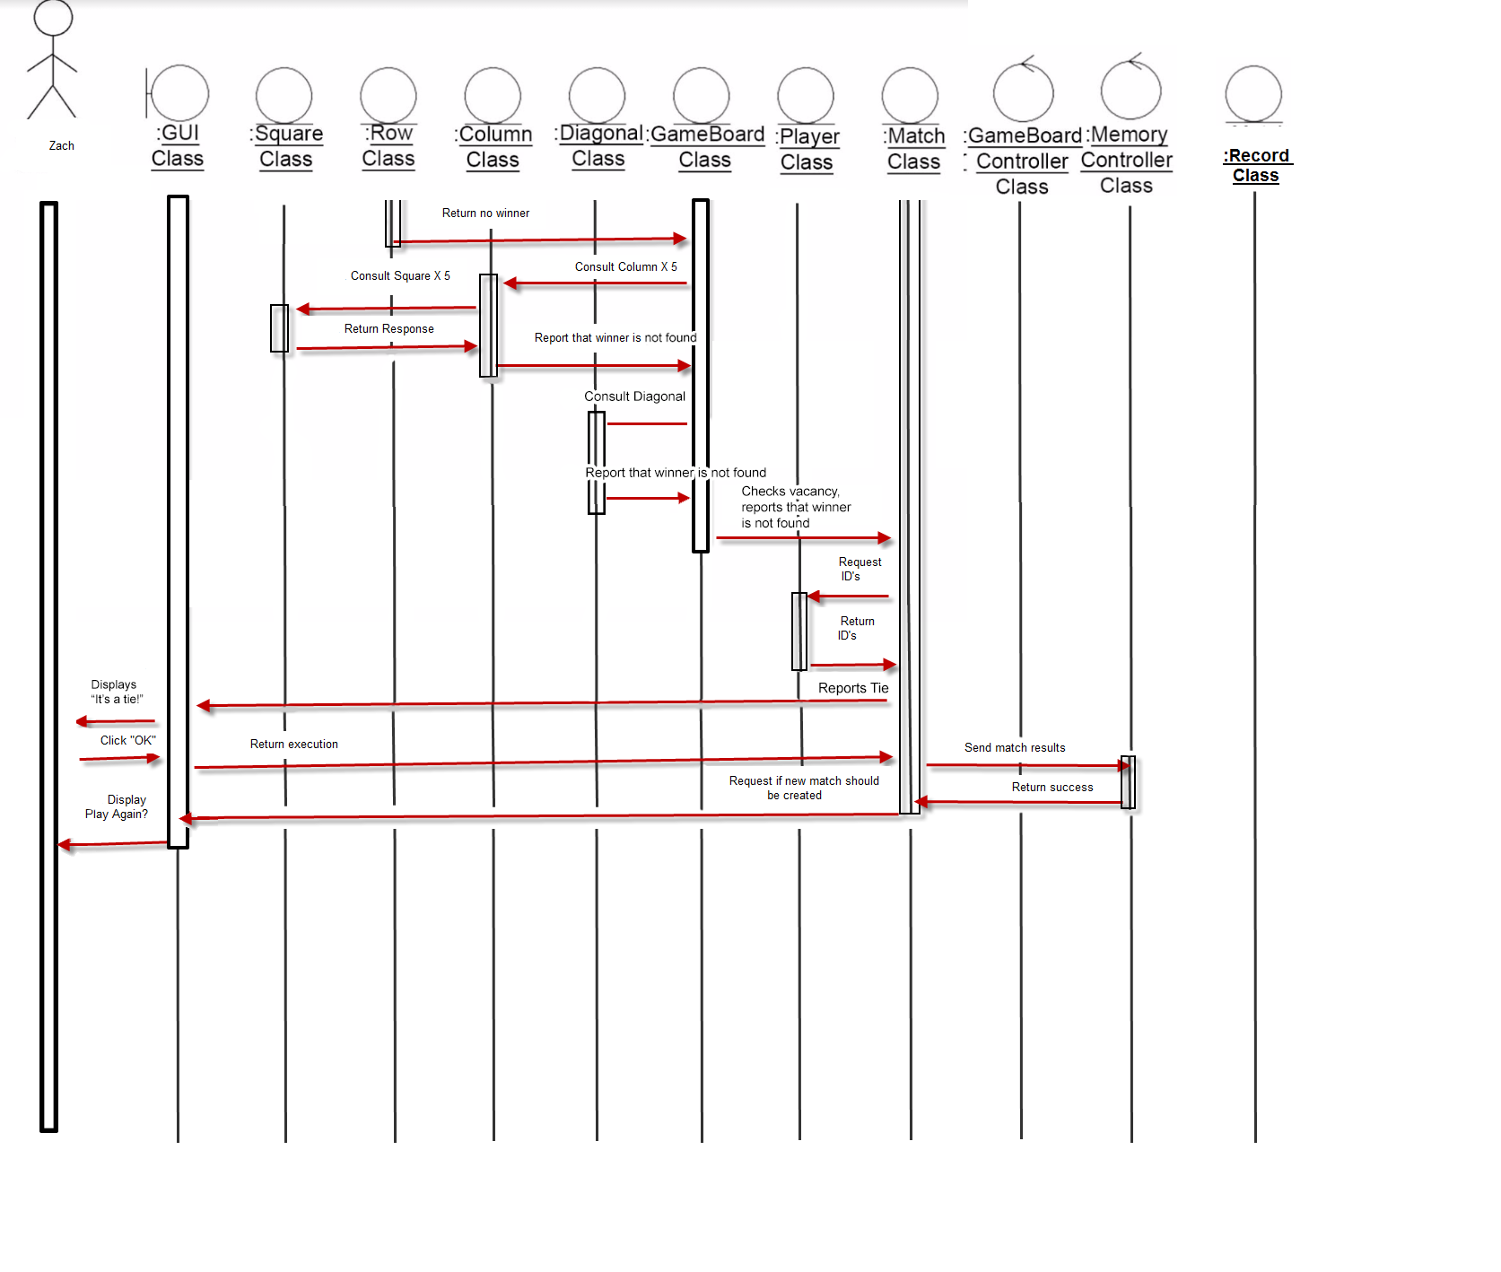

Use Case 6, Normal Scenario 1
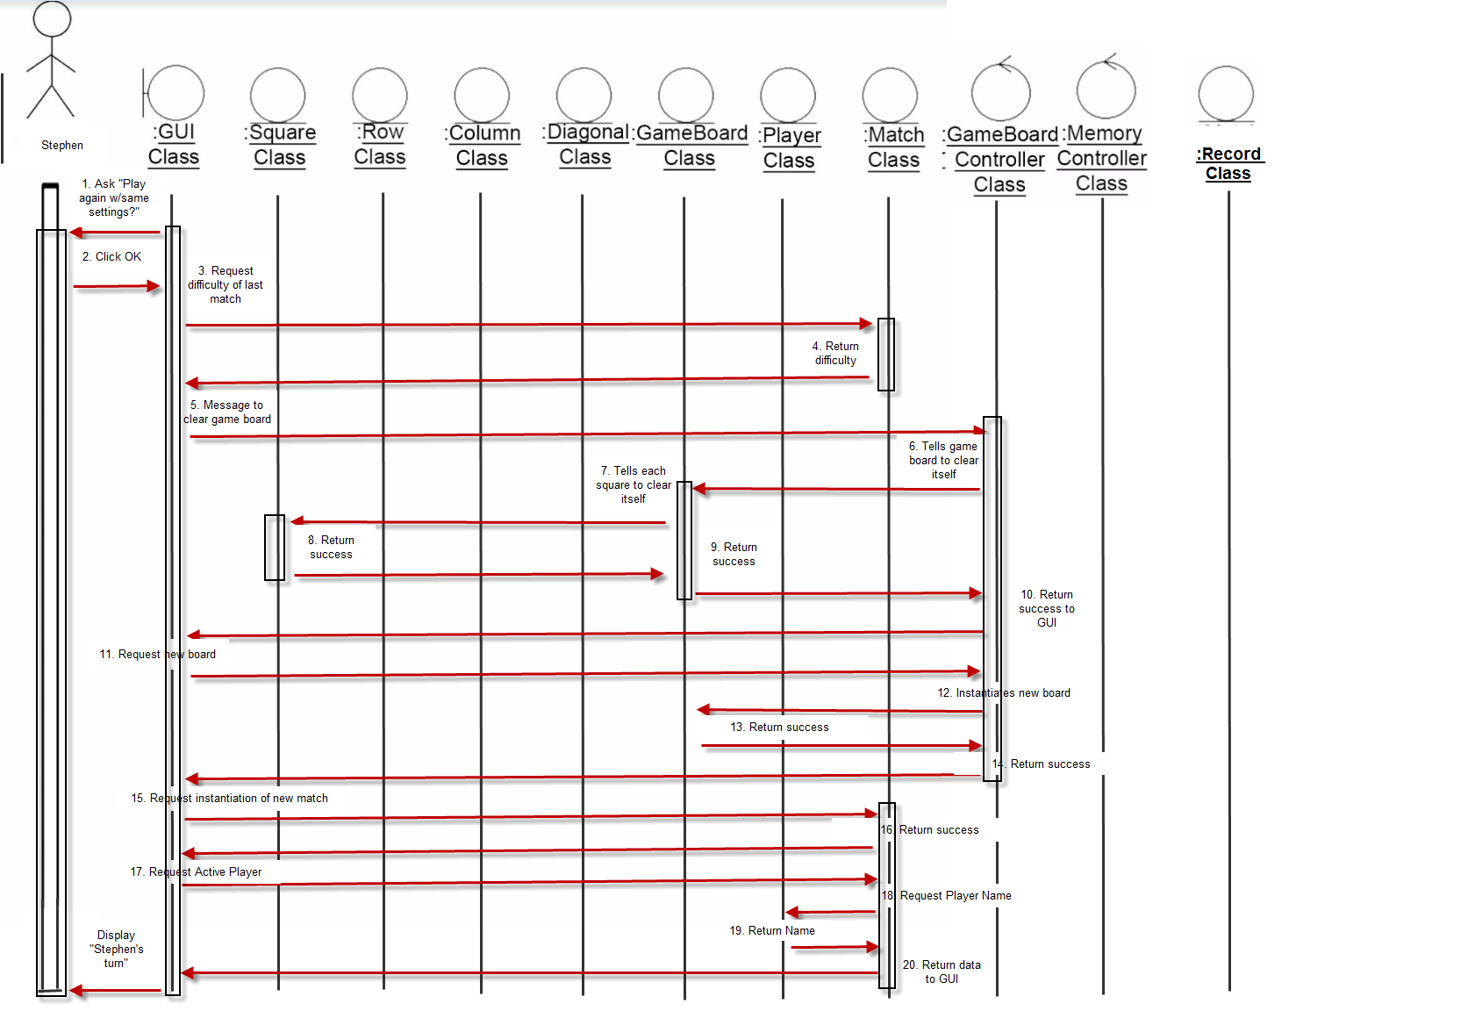

Use Case 6, Normal Scenario 2
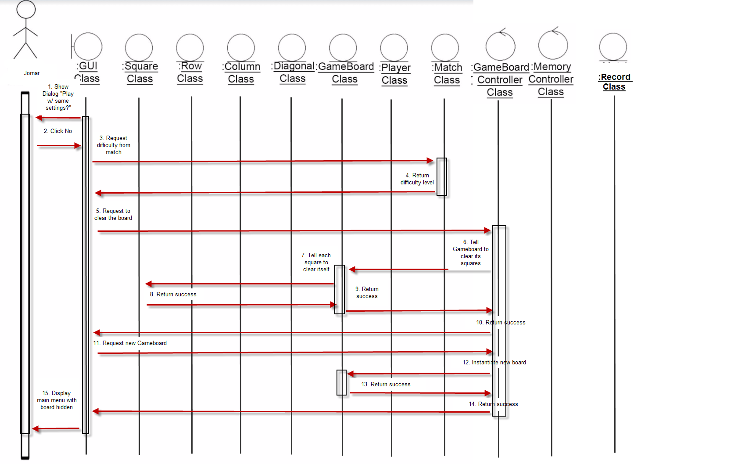

Use Case 6, Normal Scenario 3
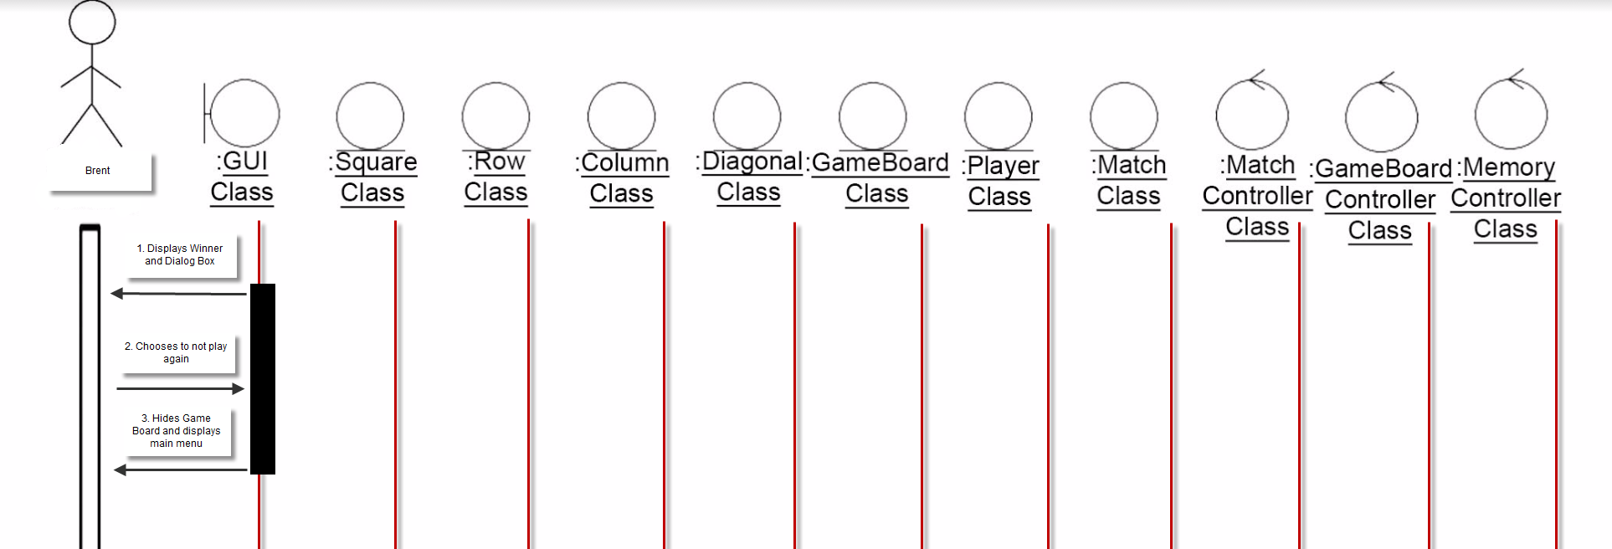

Use Case 6, Exception Scenario
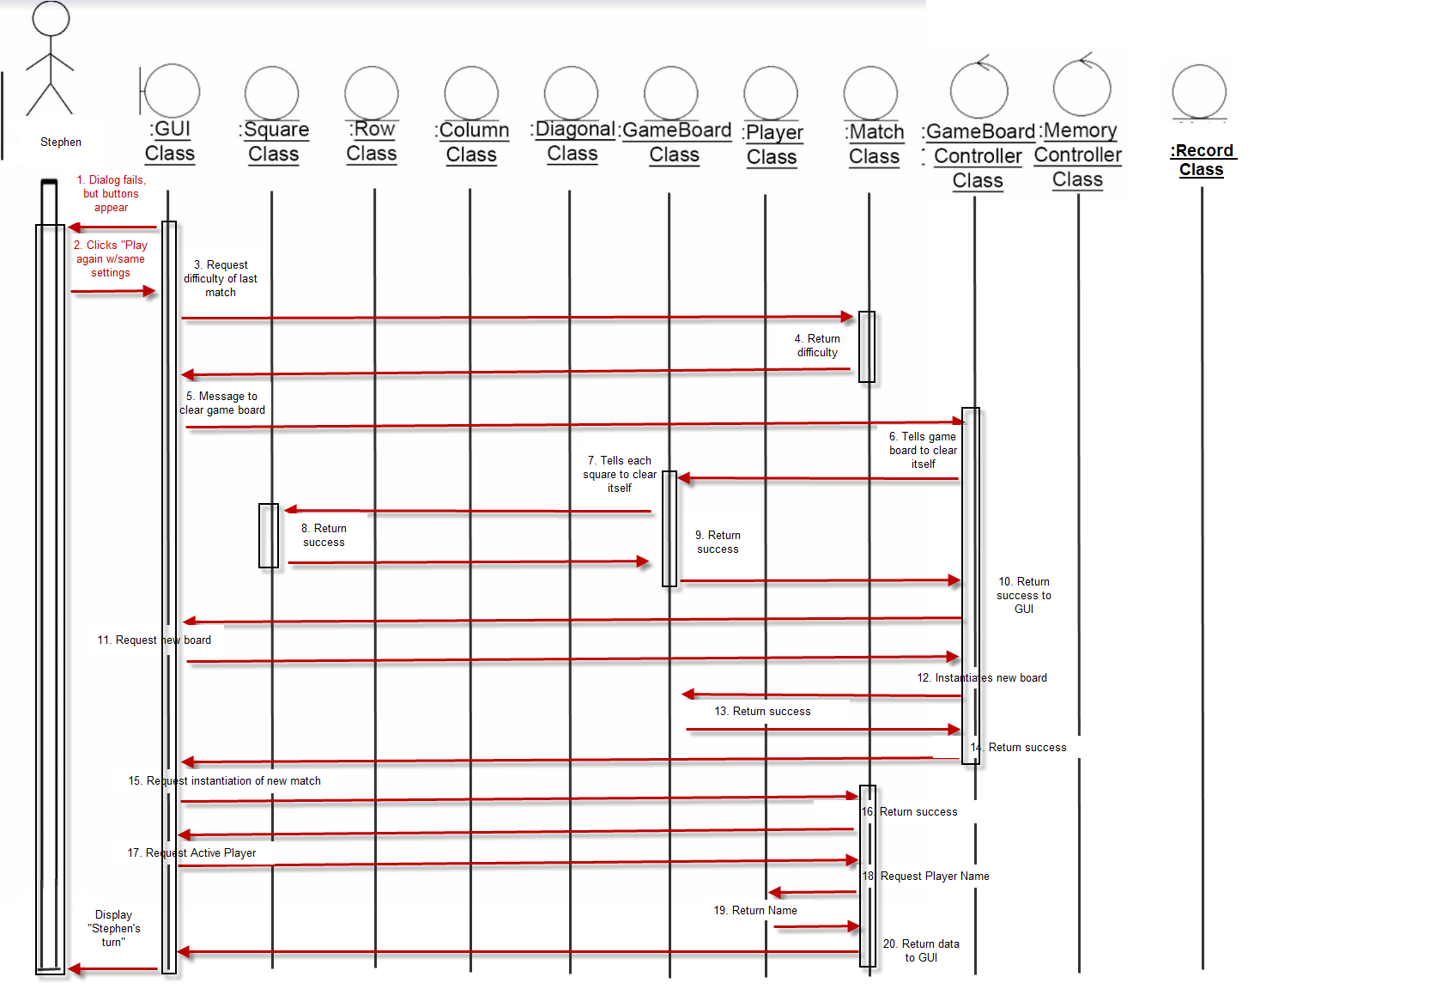

Use case 7 Scenario 1
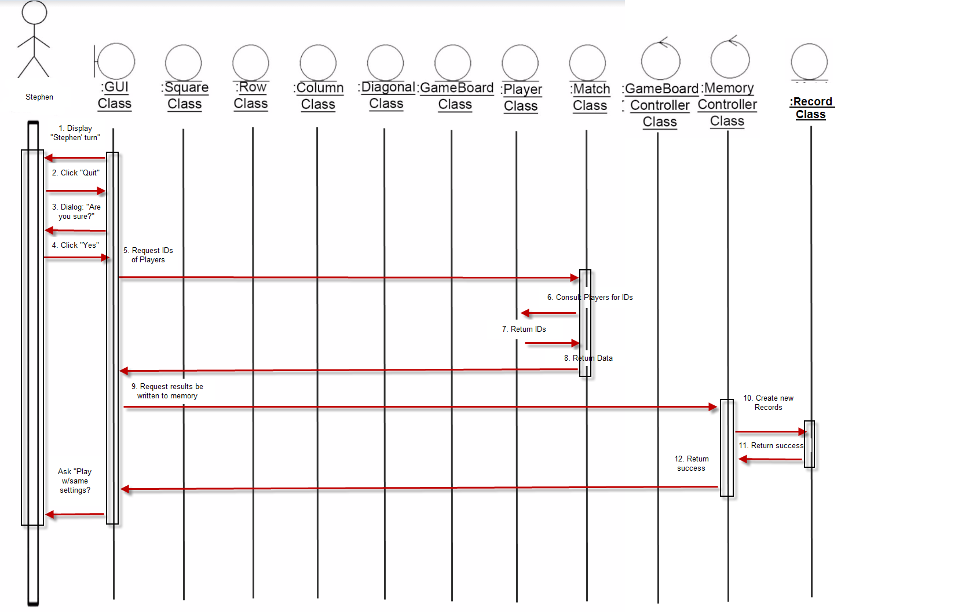

Use case 7 Scenario 2
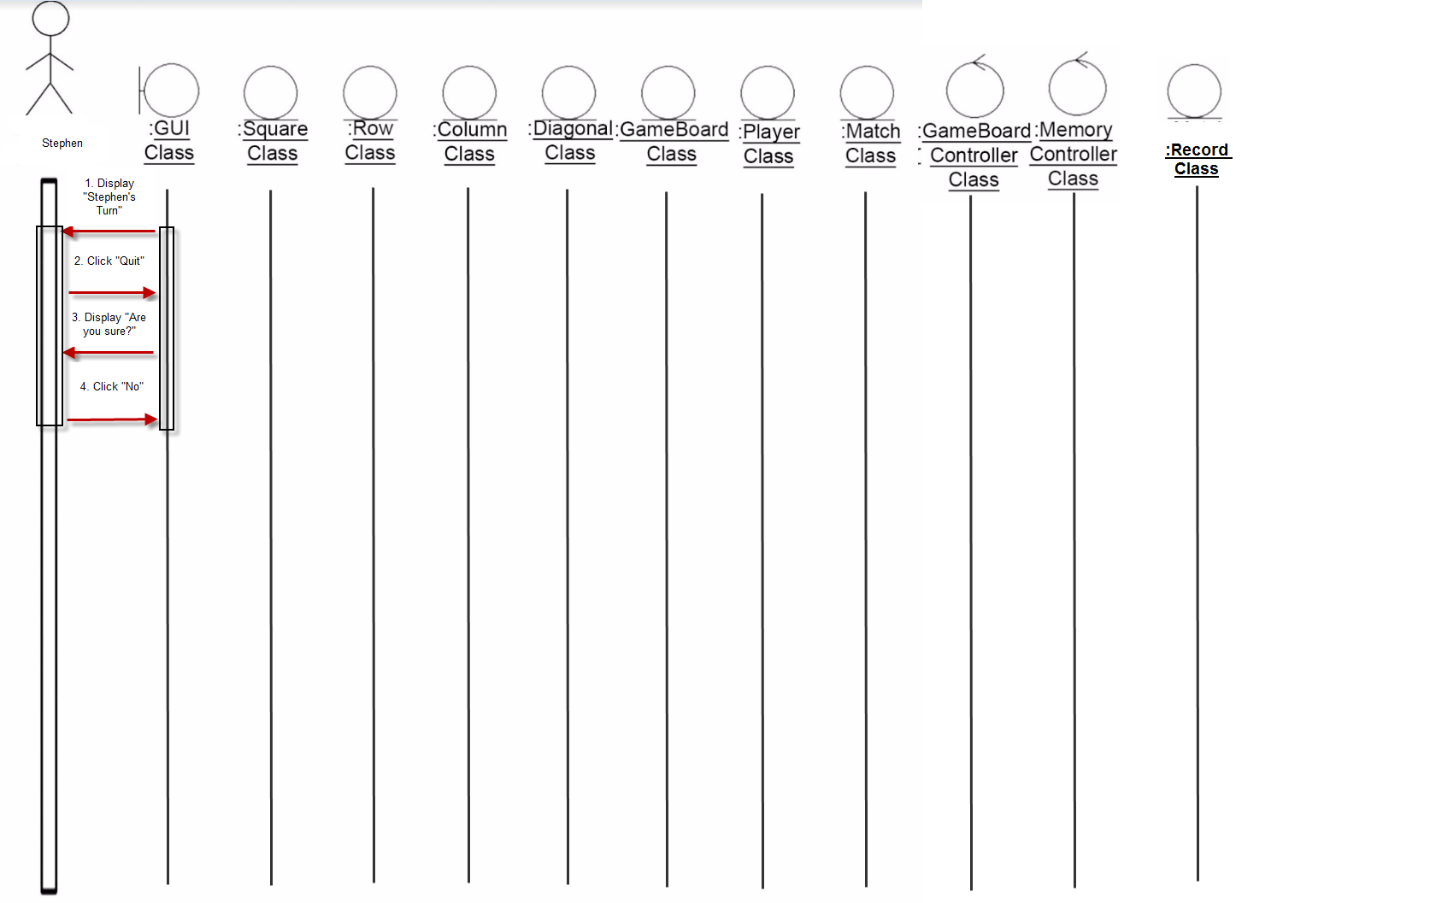

Use case 7 Exception

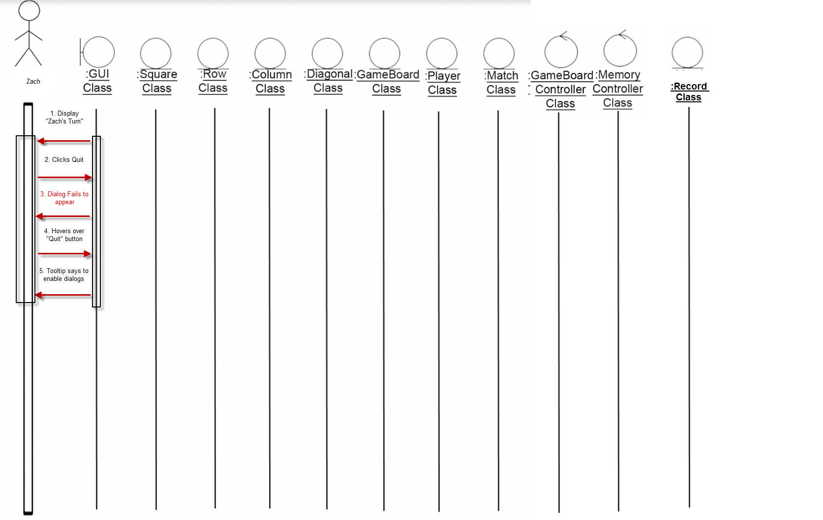

Finite State Diagrams

Gameboard
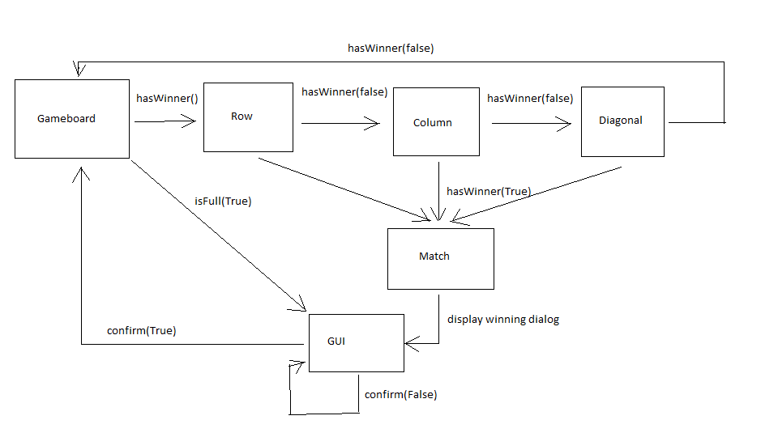

GUI CLASS
The state diagram for this boundary class shows the different events that can alter the screen displayed to the user(s). We have the following states:

Main Menu (MM). The main menu is the menu visible when the user first opens the application. It is where various settings such as match mode (i.e. Player vs. Player), user name, and difficulty are chosen. We imagine MM as a Boolean function with two parameters:

MM(match_mode, clickEnabled) where match_mode is either PVC (Player vs. Computer) or PVP (Player vs. Player) and clickEnabled is a Boolean value that represents whether or not the “Start Match” button is enabled. This button is not enabled whenever the menu is in a state of invalid input.

MM is accompanied by these functions:

matchMode() – the user toggles the match mode from the current selection.

validateOptions(player_number, acceptable_input) – after input is changed, we must check for valid input. Player_number is either 1 or 2 (representing Player 1 or Player 2) and acceptable_input is a Boolean for whether or not that user has entered valid input. For example, if Player 2 enters invalid input such as leaving the text field for the new user name blank, we would have validateOptions(2, FALSE).

startMatchClick() – the event fired with the “Start Match” button is clicked.

Game Piece (GP). The submenu for selecting a game piece. On clicking a game piece, the gpClick() function is fired.

Game Board(GB). The state in which the tic-tac-toe game board is visible to the user(s). This state is accompanied by several dialog box displays and the following events:

confirm(TRUE) – The user has clicked “Yes” in a confirm dialog.

confirm(FALSE) – The user has clicked “No” in a confirm dialog.

winner(TRUE) – The game board has reached a state where there is a winner.

dialog(OK) – User dismisses dialog box by clicking “OK”.

quitClick() – User clicks the “Quit” button.

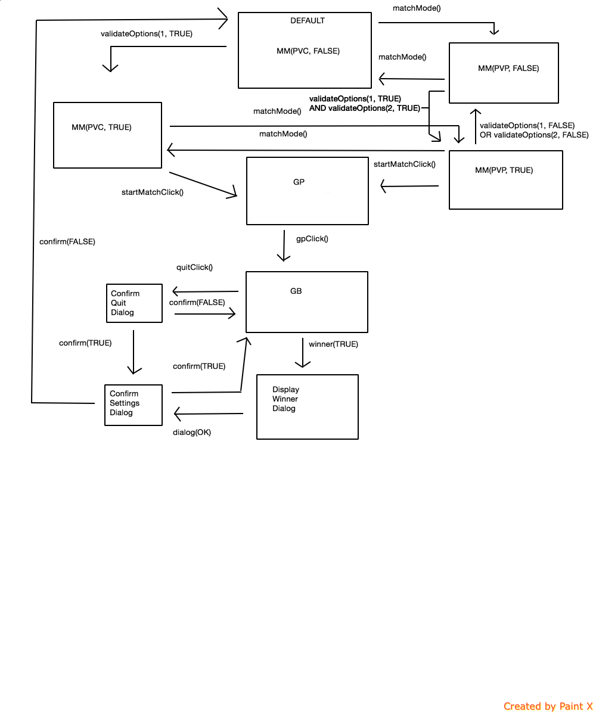

Match Class State Diagram

We consider the following four general states for the Match entity class:

P1: This represents the state where the activePlayer instance variable is set to Player 1. That is, it is Player 1’s turn to select a square on the game board.

P2: This represents the state where the activePlayer instance variable is set to Player 2. That is, it is Player 2’s turn to select a square on the game board.

Win: This represents the state where a player has won the watch and another player has lost the match. Upon arriving to this state, the Match cannot toggle the activePlayer instance variable anymore.

Tie: This represents the state where all of the squares have been selected and there is no longer the possibility of a winner and loser of the Match. Upon arriving at this state, the Match cannot toggle the activePlayer instance variable anymore.

We consider the following state transition functions:

makesMove(): Represents the action of a player making a selection on the grid that doesn’t result in a win or tie. The Match then toggles whose turn it is.

gb.hasWinner(): Represents the point where a Match’s gameboard reference has a winner.

gb.hasTie(): Represents the point where a Match’s gameboard reference has a tie.

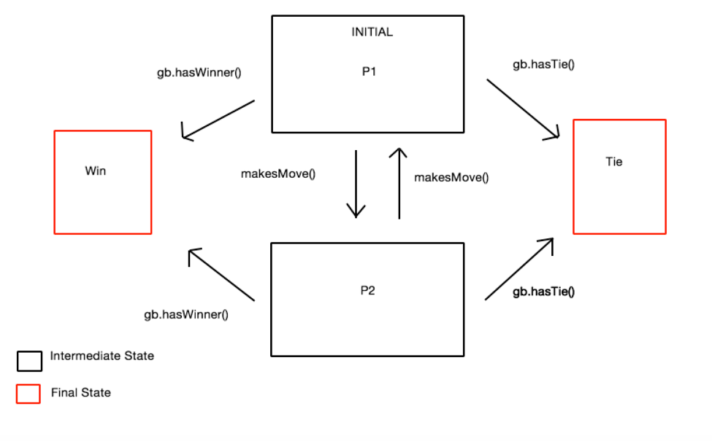

The following are additional classes that did not necessitate a state diagram:

GameBoardController. This control class serves as a utility class for more complex algorithms that relate to managing a game board. It has no instance variables of its own, so there are no real “states” for it to be in.

Player and Record. These are entity classes; however, once they are instantiated they only call a few accessor and mutator methods. They never change states after instantiation.

MemoryController. This control class, like GameBoardController, serves more of a utility function for creating and storing Record objects. It has no real “states” to speak of.

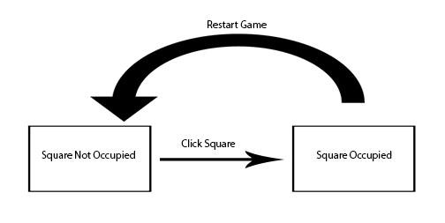

Square Class State Diagram
The square class has 2 states either occupied or not occupied. Once the square is clicked it becomes occupied after the game ends the square returns to being unoccupied.

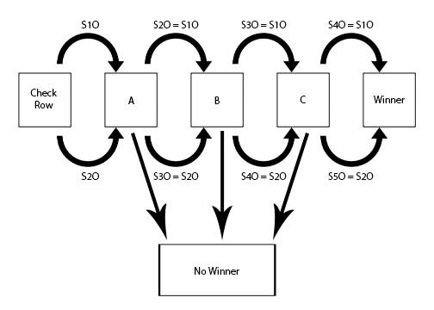
Row Class State Diagram
S#O: This represents square number occupied if the square is occupied then it moves on.
S#O = S#O: This represents if the squares occupied are equal and it will iterate until it gives a winner having 4 in a row or if the values aren’t equal.
A, B, C: These store if the values are equal or not to tell the software whether to continue checking the row or if there is no winner in that row.
Winner: This returns a winner if there are 4 consecutive squares occupied by the same object.
No Winner: This returns no winner in the row and allows the game to continue and will check again upon next move.

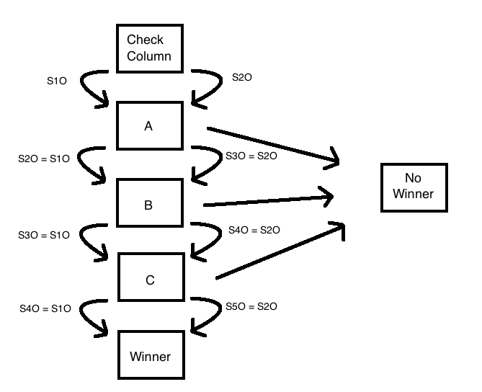
Column Class State Diagram
S#O: This represents square number occupied if the square is occupied then it moves on.
S#O = S#O: This represents if the squares occupied are equal and it will iterate until it gives a winner having 4 in a row or if the values aren’t equal.
A, B, C: These store if the values are equal or not to tell the software whether to continue checking the row or if there is no winner in that row.
Winner: This returns a winner if there are 4 consecutive squares occupied by the same object.
No Winner: This returns no winner in the row and allows the game to continue and will check again upon next move.
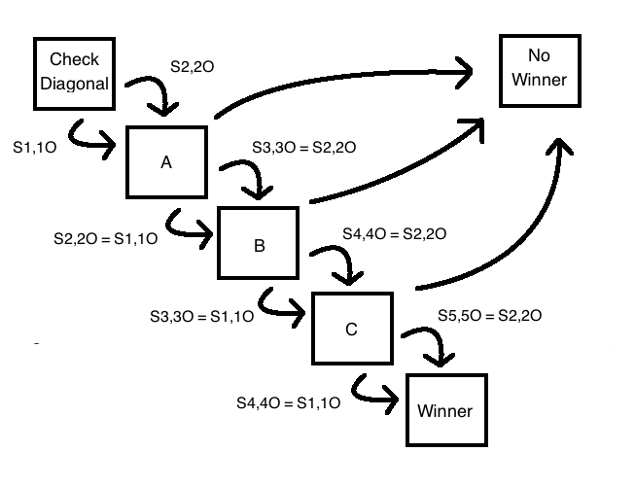

Diagonal Class State Diagram
S#O: This represents square number occupied if the square is occupied then it moves on.
S#O = S#O: This represents if the squares occupied are equal and it will iterate until it gives a winner having 4 in a row or if the values aren’t equal.
A, B, C: These store if the values are equal or not to tell the software whether to continue checking the row or if there is no winner in that row.
Winner: This returns a winner if there are 4 consecutive squares occupied by the same object.
No Winner: This returns no winner in the row and allows the game to continue and will check again upon next move.

User Interface

Others

